**סלניום: שיעור 3 - תרגילים**

**Exercise 1:**

1. Must run this on Chrome (not work on FF in 100%)
2. Open <https://login.salesforce.com/>
3. Fill in the User +Password + Remember me
4. Click on ‘Login’ button
5. Get the error message and print it
6. Click the ‘Forgot your password’ link
7. Insert your name
8. Click on ‘Continue’ button
9. Get the error message and print it

**Exercise 2:** (Pay Attention: if you do not get the list, add sleep to your code)

1. Get all links in this page <http://www.wix.com/jobs/locations/tel-aviv/positions>
2. Get list of all jobs and print it
3. Search for the word ‘Engineer’ in the list of jobs
4. Print only the jobs that has ‘Engineer’ in it

**Exercise 3:**

1. Do the same scenario as in practice #2,   
   but instead of writing everything in the main,   
   create a class called ‘Jobs’:
   1. Create the driver in the main and pass it to the class using the constructor
   2. Add methods that printAllJobs that contains ‘Engineer’ in the job.and call this method from the main.

**Exercise 4:**

1. Open <https://www.saucedemo.com/index.html>
2. Do Login
3. Add to cart 2 products
4. Press the cart button.
5. Click on ‘CHECKOUT’ button
6. Fill your information and Click ‘CONTINUE’ button.
7. Click on ‘FINISH’ button
8. Get the message and print it (Thank you message).

**Exercise 5:** (challenging)

1. Open <https://www.skyscanner.co.il/>
2. Fill the ‘From’ field with LHR.
3. Fill the ‘To’ field with FCO.
4. Press the ‘Search Flights’ button

**Exercise 6:**(challenging)

1. Open <https://www.ebay.com/sch/ebayadvsearch>
2. Search for ‘guitar’.
3. Change category to ‘Musical Instruments & Gear’ (Use Select object).
4. Update price between 50-60ILS
5. Click ‘Action’ option (Buying formats)

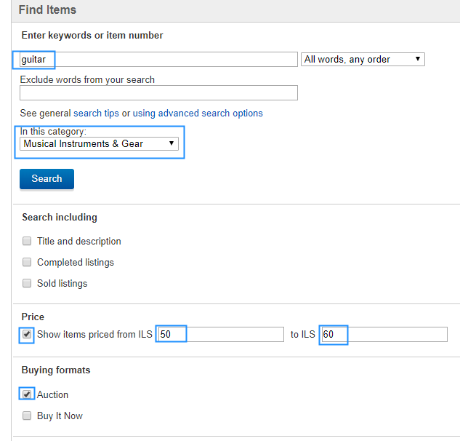

1. Press the Search button on the bottom of the page
2. Check that all prices are between 50-60 ILS

את שיעורי הבית שילחו באמייל אל [homework@automation.co.il](mailto:homework@automation.co.il)   
על מנת שנוכל לעבור עליהם, לתת לכם הערות ולשפר את יכולות הקוד שלכם.